SmartHirePro

Hrushikesh Joshi1, Yash Jani2, Seungah Choi3, Sujay Sail4, Ashish Sudam5, Yadu VamsiKrishna6,

Sreeja Karukonda7, Aashlesha Shirole8

*Seidenberg School Of Computer Science and Information Systems - Pace University*

1hj85754n@pace.edu, 2yj16719n@pace.edu, 3sc02316n@pace.edu, 4ss36001n@pace.edu,

5as90561n@pace.edu, 6sk20404n@pace.edu, 7as43084n@pace.edu, 8vu49059n@pace.edu

***Abstract*—SmartHirePro, a job recommendation system designed for recent graduates and young professionals, tackles the challenge of navigating the online job market. It analyses resumes to extract key skills using YAKE!, a keyword extraction technique that prioritizes the most relevant skills. Leveraging a large language model, SmartHirePro then matches these skills with relevant job postings and retrieves them from an external job board API. The system employs a multi-stage approach that includes resume preprocessing, skill extraction, and job matching based on skill similarity described on the resume and the job posting description. By recommending suitable jobs and offering insights into their skill set, SmartHirePro empowers job seekers to navigate the online job market more effectively and potentially chart their career paths.**

***Keywords***— **Keywords, Extraction, Skills, Recommendations, Jobs**

1. Introduction

The way people look for work has changed significantly as a result of the internet's explosive expansion. Employers are starting to use job boards to find talent as more and more job seekers publish their resumes and professional details online. According to a Jobvite survey, a large proportion of job searchers who apply online are recent college grads or postgraduates, and a considerable proportion of recruiters use social media to find candidates. This pattern emphasizes how important job searching online is becoming.

It can be a real pain to look for suitable work online if you're a recent graduate or a young professional still building your resume. Their selection of filters is limited, and university career services often do not have sophisticated matching algorithms. Ideally, these job sites would also serve as career advisors, connecting users with in-demand expertise.

To assist job seekers in overcoming the aforementioned challenges, this study introduces SmartHirePro, a cutting-edge recommendation system. SmartHirePro provides clients with two primary recommendations, namely jobs, and skills, by utilizing collaborative filtering algorithms and text mining with an emphasis on students and young professionals. By recommending suitable employment, SmartHirePro helps people in their job hunt. Furthermore, the skill recommendations help users pinpoint areas where they might need to further develop to match the demands of today's job market. By using this integrated technique, users are better able to find suitable employment opportunities and get insightful knowledge that will enhance their skill sets and increase their marketability.

1. Literature Review

In the dynamic job market, job suggestion systems have grown in importance as resources for companies and job seekers alike. Through the identification of appropriate work prospects based on their qualifications and expertise, these systems help job seekers. This literature review examines current methods for skill extraction and job recommendation systems, emphasizing how they apply to SmartHirePro, a new job recommendation system that focuses on resumes.

*A. Job Recommendation Systems*

A framework for recommending career paths, called CaPaR [1]: This study presents CaPaR, a system that uses collaborative filtering techniques and text mining to recommend skills and jobs to users. CaPaR is aimed at students and young professionals, much like SmartHirePro. However, one important difference is that SmartHirePro's method might not include collaborative filtering.

Effective re-education utilizing resumes for career recommendations is conceivable in work environments that are changing more and more [2] This study investigates how career counseling might be given using resumes in a changing labor market. SmartHirePro focuses on connecting talent to employment; this may pave the way for future SmartHirePro capabilities enhancements. While the [2] technique delivers significant insights for identifying skill shortages and recommending re-education opportunities, SmartHirePro matches talent to jobs.

*B. Skill Extraction Techniques*

Extracting skills from resumes is one of the most crucial phases in job recommendation systems. The papers that follow look at different strategies for completing this task:

Method for Combining Multiple Features Extraction of Keywords TextRank [3] is based on the following: This study presents an extraction strategy for keywords based on TextRank. For SmartHirePro to identify competencies from resumes, keyword extraction is necessary. While YAKE! is employed by SmartHirePro, this study provides a different approach (TextRank) for potential analysis and comparison.

YAKE! Multiple local features are used to extract keywords from a single document [4]: This paper presents YAKE!, a multi-feature keyword extraction technique. YAKE! is utilized by SmartHirePro to extract abilities from resumes. This document provides important insights into the internal workings of YAKE! and the reasoning behind the features that were selected.

*C. Areas for Further Exploration*

The following important areas require further research after a careful evaluation of the literature:

Adapting to Shifting Labour Markets In what ways do the existing job recommendation systems address the challenge of rapidly evolving labor markets and increasing skill requirements [2] and other similar works could provide helpful information in this regard.

Contrasting several approaches to skill extraction How precise and effective, in comparison to YAKE!, are alternative keyword extraction methods for skill extraction from resumes, such as TextRank [3].

*D. Conclusion*

The research that has already been done on skill extraction methods and job recommendation systems has been reviewed in this literature review. The reviewed works provide insightful information that guides SmartHirePro's development. Future studies should look into different methods for extracting skills for better performance, as well as how job suggestion algorithms might adjust to changing job markets.

1. Relevance

From manual resume checks to Applicant Tracking Systems (ATS) that automate some portions of candidate assessment, technology has drastically changed traditional recruitment processes. Since keyword matching plays a major role in these systems, applicants with unusual career trajectories or a variety of skill sets that don't precisely fit job descriptions may be overlooked.

Traditional recruitment methods, from manual resume reviews to Applicant Tracking Systems (ATS) which consequently complete parts of the candidate screening process have been significantly changed by technology. These systems are primarily based on one of the main methods keyword matching, which implies that candidates who have not generally developed career paths or a wide range of skills that don't perfectly match job descriptions could be disqualified.

The development of Artificial Intelligence and machine learning provides a deeper evaluation of resumes and job advertisements which addresses these limitations. Semantic analysis is one of the good examples that helps to resolve the correctness of matching jobs by giving a better understanding of synonyms and context. There are still further innovations possible because these complex systems have not yet been fully adopted.

However, there is still a strong need for user-friendly, effective, and successful job-matching services that meet the needs of a wide range of employers and job applicants, especially in rapidly developing labor markets. The biggest difficulty for many systems is matching people's soft skills to requirements that go beyond keyword matching.

*A. Building the Case for Usefulness*

These gaps have been closed in this study by developing a more accessible and user-friendly platform using artificial intelligence that improves resumes and job matching. Rather than overloading the keywords, the project's main focus on talent and experience extraction along with the utilization of more advanced NLP approaches will help in better understanding the meanings and context of the keywords. Users will be able to determine whether their resumes are aimed at their preferred job description.

There is improved accuracy and relevance of the job matches that AI has brought to the industry, which has increased productivity in the hiring process both for the employers and the candidates. SmartHirePro increases the chances for qualified candidates to find relevant opportunities that match their skill sets. For employers, SmartHirePro can have a more sophisticated pool of applicants to choose from and use standardized search techniques to search for the best matching candidates for the job. ⁤

*B. Advancing the understanding and Significance*

Ever since the rise of Artificial Intelligence, the HR department has also started using AI during the recruiting process to match the huge growth in workforce demand. Traditionally, recruiters manually reviewed the resume but now with the help of AI, there is a service called Applicant Tracking Systems (ATS) which automatically puts the applicant’s resume in the system to go through a keyword matching to the job description. This has been a hot topic in the job market since the ATS just heavily relies on keyword matching, ATS does not take account of the applicant's actual resumes and only takes in the keywords that are extracted from the resumes, and if it doesn’t fit the job description fully then ATS will just automatically decline the applicant. Some recent advances in AI and machine learning tried to overcome some of these limitations by offering more precise assessments using techniques such as “semantic analysis”, (the machine is not only able to process long strings of characters and locate them but also allows you to store, manage, and retrieve information based on meaning and logical relationships. in the end, can relate to each other). However, they are not perfect, and the need for improvement is still essential.

Moving on, there needs to be a system that is capable of matching individuals’ soft skills with job criteria as well as the hard skills beyond a simple keyword-matching algorithm. To fulfill an inclusive recruitment process using an AI program to automate the process for the HR department, solving this issue will not only benefit the applicants but also businesses that are looking for that perfect match candidate for their company.

1. Methodology

A multi-stage recommendation system, SmartHirePro matches users with jobs based on their resumes. Below is a thorough explanation of every phase:

*A. Resume Preprocessing:*

At this point, the resume is guaranteed to be prepared for efficient skill extraction. It involves several smaller processes:

* Noise removal: Extraneous details such as headers, footers, contact information, and style components are removed. Methods such as pre-defined elimination patterns and regular expressions can be used for this.
* Formatting Correction: Formatting inconsistencies are resolved. This could entail fixing any layout problems, unifying spacing and font variances, and turning various bullet point styles into a common structure.

*2. Skill Extraction:*

Using the pre-processed CV, this important step determines the applicant's essential skills. YAKE! a keyword extraction method that SmartHirePro uses, has the following benefits:

* Multi-Feature Analysis: YAKE! gives each keyword a relevance score based on several factors[4]. Document frequency (the number of times a keyword appears in the resume), document position (words in titles or strong fonts may be more important), and maybe part-of-speech analysis (concentrating on nouns and verbs indicative of talents) are some examples of these features.
* Tailored Extraction: YAKE! Let you customize the extraction process with user-defined parameters[4]. For example, stop-word lists can be used to remove common terms that don't indicate abilities and minimum character length filters can be used to delete irrelevant single words.
* Top-Ranked Skills: The user's most prominent skills are represented by a predetermined number of top-ranked keywords that YAKE! choices based on the relevance scores that have been assigned. This guarantees that for accurate job matching, the system concentrates on the most important abilities.

*C. Job Matching and Recommendation:*

Linking the user's talents to appropriate career prospects is the goal of this stage. There are various steps in the process:

* Job Data Acquisition: To gain access to a vast database of job ads, SmartHirePro uses an external job board API. The API selected will vary depending on variables such as access costs, update frequency, and data coverage.
* Parsing a job description: To maintain uniformity, job descriptions may go through some basic cleaning and parsing, much like resume preprocessing. This could entail eliminating extraneous formatting components or HTML tags.
* Similarity Matching: SmartHirePro uses a broad language model (e.g., spaCy's en_web_core_lg) to evaluate how well the user's abilities match the job requirements. This model does more than just match keywords. By representing words and phrases as numerical vectors that capture their semantic relationships within the text, it conducts vectorization. The model determines a similarity score by comparing the skill vectors that were taken from the resume with the vectors from the job description. The degree of alignment between the user's talents and those listed in the job description is reflected in this score.

Fig. 1 An illustration of the system architecture

The precise methods employed for spelling and grammar correction, noise reduction, and formatting correction can be selected according to the features provided by the libraries or APIs that are available. Pre-built modules for 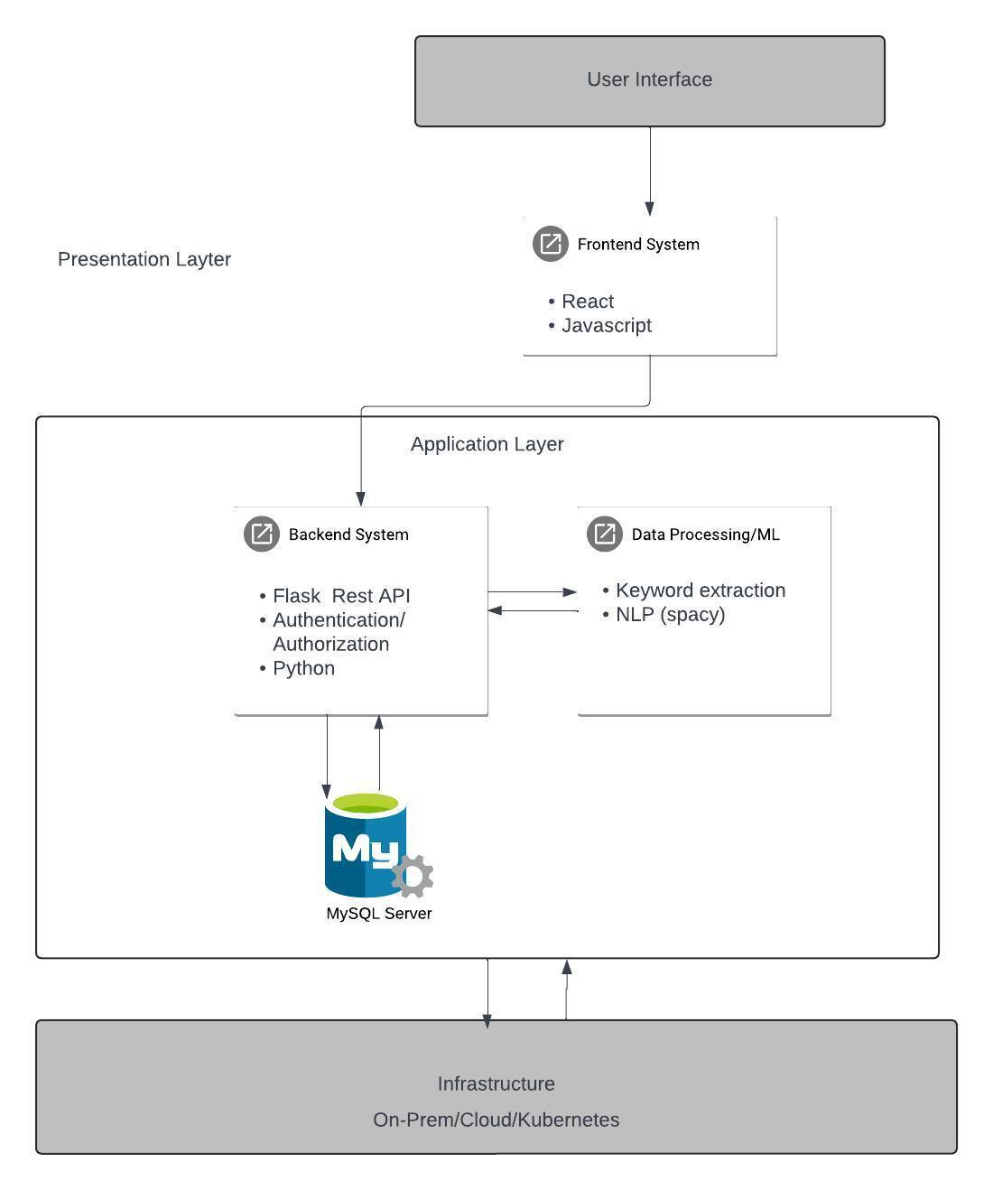these tasks are generally available from open-source libraries such as spaCy or NLTK.

YAKE! is a good fit for this work because of its adaptability and capacity to give priority to pertinent abilities[4]. To maximize skill extraction accuracy, many parameter settings can be experimented with.

The more comprehensive en_web_core_lg model is selected for job matching due to its vectorization capabilities, which allow a more nuanced understanding of the semantic relationships between skills mentioned in the resume and job descriptions. For named entity recognition tasks, a smaller spaCy model, such as en_web_core_sm, might be sufficient.

A deeper grasp of the many steps in SmartHirePro and the reasoning behind the selected technology is provided by this thorough methodology section. Large-scale social and economic ramifications also stem from this study. Raising the caliber of job matches can help ensure equitable pay, lower attrition, and increased job satisfaction. Thus, workforce development is supported, highlighting the project's noteworthy impact.

1. Conclusion

With SmartHirePros’s excellent emphasis on advanced skill matching through resume analysis, SmartHirePro offers a fresh take on job suggestion systems. This will also expedite users’ job search and perfect matching job recommendations based on their skill set. SmartHirePro is designed to empower young professionals and recent grads, who will benefit from the great service that SmartHirePro has to provide. Some other potential benefits of SmartHirePro extend beyond better job search performance. Through insights into a user's skill set, it can promote career development and increase self-awareness. Since the Resume parsing program works a lot like an ATS (Applicant Tracking System), extracting user’s resume keywords, users can see the keywords that are extracted to see if it will be appropriate for what they are aiming for as a dream job. In addition, SmartHirePro can democratize work chances for people with unconventional career histories by emphasizing talents/skill sets rather than the typical experiences that are written on the resume. This technology will be helpful for both companies and job seekers. Job seekers will be able to successfully present their abilities/skill sets and make connections with appropriate positions, while companies that are hiring talents can use the system to find qualified applicants based on skills and streamline the recruitment process. However, users must be aware that bias in skill extraction algorithms could be present and not have an excessive dependence on automation. To protect user privacy strong data security procedures are also necessary. SmartHirePro presents a bright future for an employment recommendations system that could be advantageous to all parties involved. further studies can improve its precision and investigate new aspects that could propose new augments that SmartHirePro could influence on the labor market.

Bibliography

[1] B. Patel, V. Kakuste, and M. Eirinaki, “CaPaR: A career path recommendation framework,” in *Proceedings - 3rd IEEE International Conference on Big Data Computing Service and Applications, BigDataService 2017*, Institute of Electrical and Electronics Engineers Inc., Jun. 2017, pp. 23–30. doi: 10.1109/BigDataService.2017.31.

[2] S. Ashrafi, B. Majidi, E. Akhtarkavan, and S. H. R. Hajiagha, “Efficient Resume-Based Re-Education for Career Recommendation in Rapidly Evolving Job Markets,” *IEEE Access*, vol. 11, pp. 124350–124367, 2023, doi: 10.1109/ACCESS.2023.3329576.

[3] W. Guo, Z. Wang, and F. Han, “Multifeature Fusion Keyword Extraction Algorithm Based on TextRank,” *IEEE Access*, vol. 10, pp. 71805–71813, 2022, doi: 10.1109/ACCESS.2022.3188861.

[4] R. Campos, V. Mangaravite, A. Pasquali, A. Jorge, C. Nunes, and A. Jatowt, “YAKE! Keyword extraction from single documents using multiple local features,” *Inf Sci (N Y)*, vol. 509, pp. 257–289, Jan. 2020, doi: 10.1016/j.ins.2019.09.013.